Beyond Complaints: A Strategic Analysis of College Grievance Redressal System

|  |  |  |
| --- | --- | --- |
| **Chandresh Bind**  *Department of Computer Science and*  *Engineering*  Raj Kumar Goel Institute of Technology, Ghaziabad  *chandreshbind652@gmail.com* | **Chirag Goyal**  *Department of Computer Science and*  *Engineering*  Raj Kumar Goel Institute of Technology, Ghaziabad  *chiraggoel98262@gmail.com* | **Ayush Rai**  *Department of Computer Science and Engineering*  Raj Kumar Goel Institute of Technology, Ghaziabad  *raiayushjnv@gmail.com* |

***Abstract -* The Grievance Redressal System (GRS) aims to look into the complaints lodged by any student and redress it as per requirement. The students can state their grievance regarding any academic and non- academic matter within the campus through the online and grievance/ suggestion box. The institution aims at solving the grievances of the students within stipulated academic and non- academic matter within the campus through the online and grievance/ suggestion box. The institution aims at solving the grievances of the students within stipulated time.**

***Key Words*: Grievance*,* Redressal,GRS Application*,* Online*,* Grievance/ Suggestion Box*,* Students, Institution.**

1. INTRODUCTION

In today's fast-paced educational environment, students often encounter various challenges and issues during their time in college or university. These issues can range from academic concerns to administrative problems and can have a significant impact on the student’s overall educational experience. In order to address these issues effectively, a comprehensive and effective student grievance redressal system is needed.

A student grievance redressal system is a platform that provides students with a means of expressing their concerns and complaints regarding their educational experience. The primary objective of this system is to ensure that all student complaints are heard, addressed, and resolved in a timely and effective manner. The system is designed to provide students with a user-friendly interface that makes it easy to register their complaints and track their progress.

Cloud based Grievance Redressal Systemis developed using modern & open-source technologies like PHP with MySQL which is fully secure & easy to host on cloud. The system is designed to be user-friendly, making it easy for students to navigate and access all the necessary information.

One of the key features of the student grievance redressal system is the ability to track and monitor the progress of each complaint. This helps to ensure that all complaints are addressed in a timely and efficient manner, and that students are kept informed of the progress of their complaints. The system is also equipped with reporting and analysis tools to help university administrators understand the nature and frequency of complaints and make informed decisions to improve the educational experience for students.

The student grievance redressal system is an important tool for promoting educational accountability. The system provides a mechanism for students to hold the university administration accountable for addressing their complaints and concerns. This helps to ensure that the university is meeting its obligations to provide a quality education experience for all students.

The development of a student grievance redressal system is a crucial step toward creating a more student-centric and accountable education system. By providing students with a platform to voice their concerns, the system helps to ensure that all complaints are heard, addressed, and resolved in a timely and effective manner. Furthermore, the system is designed to promote a positive campus culture, promote student engagement, and promote educational accountability.

The student grievance redressal system is an innovative and important tool for improving the educational experience for students. The system provides students with a means of expressing their concerns and complaints and ensures that all complaints are addressed in a timely and effective manner. The system is equipped with features such as notifications, reporting, and analysis to improve the overall efficiency and effectiveness of the grievance redressal process. The development of a student grievance redressal system is a step towards creating a more student-centric and accountable education system.

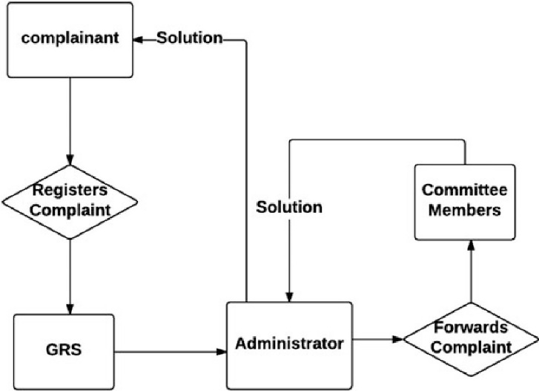

Fig.1 Grievance Redressal System

Grievance Redressal System functions for several purposes which includes ensuring the secure environment and familiarizing all faculty and students about their rights and thus it results in development of the organization are shown in fig.1.

# LITERATURE SURVEY

A Prototype for Grievance Redressal System [1] The System designed by the authors tells the complete differences between the traditional grievance system and the need for a computerized grievance system. If the association is an academic institution, then this issue becomes more sensitive and important. Students are the most vulnerable entities at educational institutions often failing to express themselves and sometimes fails to seek proper support for the issues they face arising at numerous levels.

All India Grievance Redressal Application [2]The paper published by the authors states the problems faced during offline grievance and the preventative measures taken by creating the mobile application. The grievance enrolment systems have evolved in numerous ways with the advancement in technologies to simplify the task. This paper presents the architecture of a grievance redressal operation where civilians can address any kind of complaint they're facing. The main focus of the project is pothole-related complaints. This operation will give easy access to people to put their complaints towards the government.

State-Level Students Grievance Support System [3] The paper includes the importance of an easy and fast grievance system that can be implemented for state-level institutes. Students are an essential factor in an organization. The scholar may feel dissatisfied with the service when he or she receives a delay in services. To beat this, they offer an optimized solution for the student grievances support system for improving the relationship between students and the university by representing the model of an e- complaint web-based system. The prevailing system has machined processing through the panel, principal, head of the department, and council premises. This design overcomes the restrictions of the systems regarding complication of submitting a complaint and organizing it. In this way it constitutes a state- position support system.

Managing and improving service quality in higher education [4]The paper states the importance of Higher Education in our society, and how to improve the services for scholars. Many   Higher Education institutions still ignore them at their own risk. It is especially true for service quality and this paper will focus on Higher Education service quality management and improvement. The paper aims to discuss these issues. The paper implements Schneider and Bowen's model of the three tiers of service organizations and service quality management and improvement methods, in Higher Education institutions.

The Application of Service-Oriented Architecture in E-complaint System [5**]**The paper tries to improve the relationship between citizens and government by presenting a new model based on service-oriented architecture. The researcher tried to improve the relationship between citizens and government by presenting a new model based on Service Oriented Architecture (SOA). This study can also be helpful in other fields of government in terms of citizen acceptance and citizen adhesion. The results of this study can be a good reference to find out users’ needs from complaints and the significance of complaints in the body of government.

Design and Implementation of Online Students Complaint [6] The paper provides a powerful and flexible system that can use anytime and anywhere by the students. It helps to manage and accommodate complaints fast and easily thus it can know the strength and weaknesses of its body as an educational services organization then it can provide a better solution. The system used prototype version is an improved machine version of the structure, plan, and layout of the machine. It used unified modeling language (UML) to make the abstraction of the program, PHP as a language program, and MySQL as the database. The end result of the study is the grievance might be regarded as less difficult and quicker in addition to its assessment and responses.

Grievances RedressalMechanism of University Students in India- Policy and Law [7]The study is based on the analysis of complaints from students in college and how to deal with them. The system includes exclusions from admission, withdrawal from studies, abandonment, attendance, participation in examinations, non-issuance of admission tickets, unfair screening, delay in results, issuance of graduation/grade reports, harassment, discrimination based on caste, race, religion, gender, etc.

An Online Grievance Redressal system [8]The website is mainly aimed at reducing manual processing and receiving all complaints about the college, providing updates on complaints and managing data handling complaints, and facilitating the work of users and complaint resolvers. In the system, the possibility to manage users and their data complaints and their profiles can also be easily managed. The data can be easily viewed and modified as needed. The complaint management system also provides the ability to provide monthly reports used to maintain information number of complaints resolved in a given month. It also provides user verification.

A web portal for student grievance support system [9] The project provides an optimized solution for Student complaint Support System. The model uses a mechanism of conversion from manual to automation. By providing the system to students, complaints are recorded and checked by submitting samples through the system. The proposed model is based on students and institutes.

Online Grievance Management System [10]The project is to provide an optimized solution for student complaints. The proposed model of a student complaint management system can minimize student complaints. It tries to improve the relationship between students and universities by presenting a model of a web-based system for electronic student complaints. The existing system involves manual processing by committees, directors, and relevant departments. The proposed system was able to automatically complete the process using the application.

Smart complaint management system [11]The system includes a web portal that provides a login interface for students and also accepts complaints and consultations with city hall staff. It simplifies processes to easily resolve complaints, forward the complaint to a sub officer. The employee is also given the option to update the complaints progress about processing. The employee and grievance officer have the right to reject the complaint. It also has a module that keeps track of how many complaints are resolved, handled and refused and create graph to illustrate it.

Online complaint management system [12]The online complaint management system provides a way to solve problems faced by the public by saving time and eliminating corruption. The purpose of a complaint management system is to facilitate the coordination, monitoring, tracking, and resolution of complaints, to identify and address problem areas, and to provide companies with effective tools to monitor and improve their complaints handling performance and business.

# EXISTING SYSTEM

# The Traditional forum system contains public meeting or presentation involving a discussion usually among experts and sometimes audience participation. Here, person visited College/ University officials for his complains. All the arrived complaints are undergo the Administrator. Administrator distribute complaints among different departments consistent with complain type. Employees solve the issues and complain status in books manually. One of officer gives current status information of complaints from the books.

# PROBLEMS IN EXISTING SYSTEM

# The students has go to visit forum and had to form complaint against faculty /Staff / Academics/ Sanitization / Fees / Hostel etc. The complaint are going to be discussed within the presence of students, staff and a team of expert committee along side judge. The final decision making may be a time consuming therefore the student has got to revisit the forum to urge the result.

# The GRS Application would use a database to carry students complaints and reports generated by the technical team online complaint management system contains all complaint details a complaint inventory contains all complaints with its status reports the system provides the power if the students gives the incorrect information then he edit the complaint details to supply the right information to the system. The modem Grievance Redressal Systemis comprehensive suite of identify the fault supported the students provided information and generating reports for the Complaint.

1. PROPOSED SYSTEM AND ARCHITECTURE

The main objective of this project is to develop GRS Application where the students can post their complaints under different categories and view the status. GRS Application that allows students to lodge complaints and must be accessible to the Redressal Committee and respective heads. Our proposed work is GRS Application developed using PHP as a front end and MYSQL as back end. The student registers with this website by mentioning the essential details and login with reg number and password to access the facilities.

Students can post their complaints regarding errors in name, finance, and mismatch in admission quota, complaint regarding re-evaluation and alter in schedule, changes in mark sheet. All these complaints posted by students are viewed by committee and the committee decides to forward it to the institution or department based on the complaints. There is a separate login for institution and department. If the institution or department receives the complaints, and once the complaint is rectified, the status of the complaint is updated which can be directly viewed by the student.

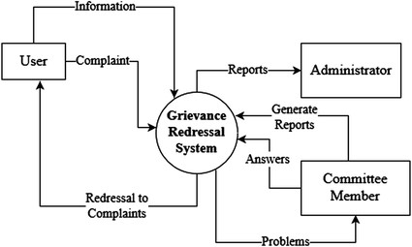

Fig.2. Architecture Framework of Grievance Redressal System for Students

Students should login to post complaints and it'll be secured in the database and Complaints will be viewed by the Redressal Committee. The Redressal Committee will forward the complaints to the Institute or Department based on the problems. The Institute or Department will take action and update the status in the database which can be viewed by the students which are shown in above fig.2.

# Modules and Their Description of Grievance Redressal System

1. Dashboard
2. Admin Login and Authentication
3. Dashboard and Complain Progress Management
4. Course Management
5. Registration Module
6. Student Login and Authentication
7. Student Complain Module
8. Complain Status Module
9. *DASHBOARD*

This is the first page for anyone who opens the GRS portal wherethe system comprises of 3 major Entity as follows:

1. Admin
2. Register
3. Student

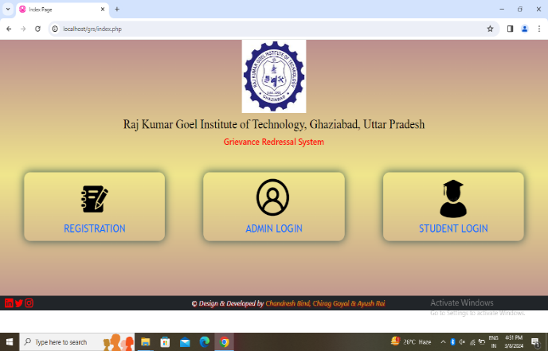

1. *ADMIN LOGIN AND AUTHENTICATION*

The admin details that are stored into a database used to authenticate at the time of login. Admin can log into his existing account through his user id and password.

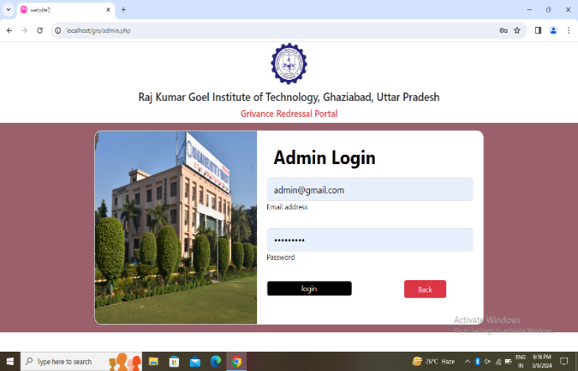

1. *DASHBOARD AND COMPLAIN PROGRESS MANAGEMENT*

Admin can view & manage the admin dashboard and all the complaints raised by the students.

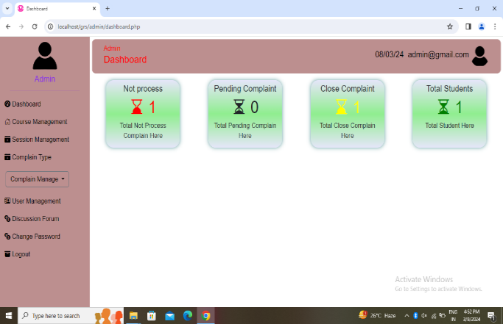

1. *COURSE MANAGEMENT*

Admin can add new colleges.

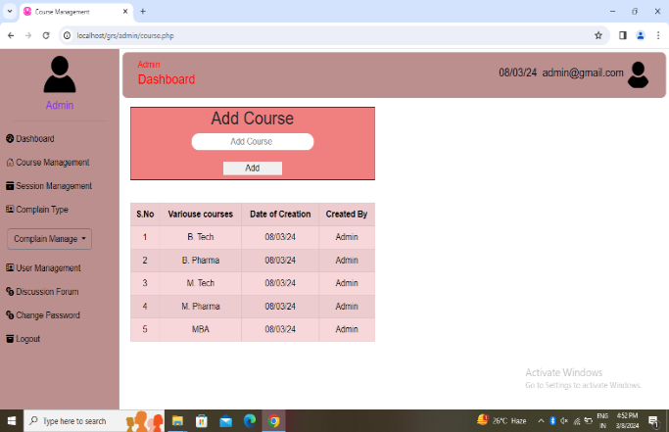

1. *REGISTRATION MODULE*

In this module, thestudent registers with this website by providing the basic details like name, date of birth, gender, department, year, mobile number and mail id.

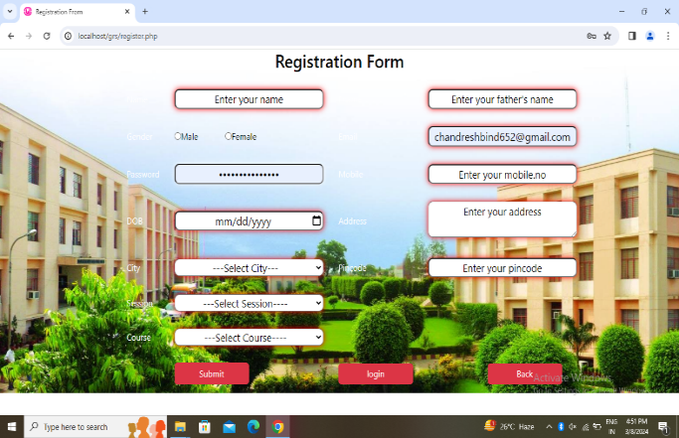

1. *STUDENT LOGIN AND AUTHENTICATION*

The registration details that are stored into a database at the time of registration used to authenticate at the time of login. Student can log into their existing account through their user id and password.

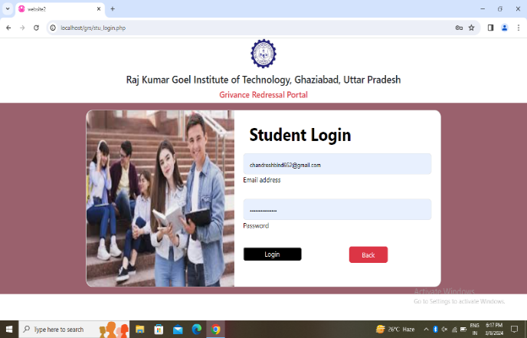

1. *STUDENT COMPLAIN MODULE*

The students may feel free to put up a grievance in writing/or in the format available in the admin dept. such as fees, hostel, admission, examination, time-table, faculty, facilities, marksheet, placement, scholarship and if there are any complaints other than this, the student can choose others and then drop it in boxes. These are stored into a database.

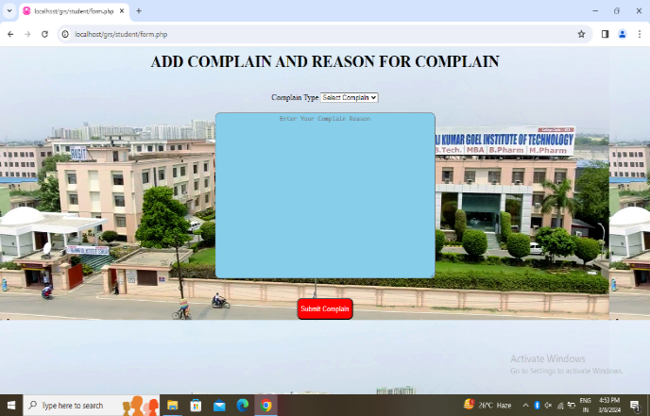

1. *COMPLAIN STATUS MODULE*

The status of the complaints can be viewed in this module.

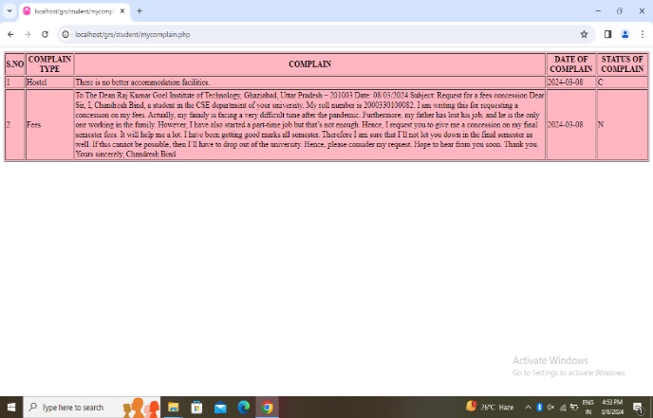

# RESULTS

The proposed system helps the students to post their complaints in various categories such as finance(fees), admission, revaluation, errors in mark sheet and others. In the above screenshot the complaints which are posted by the students can be viewed by the Redressal Committee and the Committee will send the complaints to the Institute or Department based on the problems. The institution acts upon those cases which have been forwarded along with the necessary documents within the campus through the online and grievance/ suggestion box. The institution will assure that the grievance has been properly solved in a stipulated time limit provided by the students.

# CONCLUSION

# This Grievance Redressal System is an attempt to highlight the fact that there are hardly such systems prevailing curtailing to the complaint redressed for students enrolled in numerous organizations. This paper has demonstrated a proposed GRS system for the grievance redressed of students covering various domains of complaints which could be lodged easily and thus leading to easy and sure solutions or redressed to the problems being faced by a student on a regular basis. The technologies used comprise of HTML and CSS to design a user-friendly graphical user interface, PHP, and SQL to keep track of the records at the back end. This system would be suitable for any organization for the resolution of complaints and thus lead to a qualitative and quantitative development of the educational organization.

# In future it is planned to develop our own web server to host the web application.

# Building Android Application for the system is also one of the future scope’s of this project.

# ACKNOWLEDGMENT

# The authors would like to express our sincere gratitude to all those who contributed to the development and implementation of the grievance redressal system discussed in this research paper.

# First and foremost, we extend our deepest appreciation to the faculty members and administrative staff of RKGIT, whose support and guidance were invaluable throughout the process. Their expertise and dedication greatly enriched our understanding of the complexities involved in establishing an effective grievance redressal mechanism.

# Furthermore, we would like to thank all anonymous and eponymous reviewers for their insightful comments.

# Last but not least, we extend our heartfelt thanks to our families and friends for their unwavering support and encouragement throughout this endeavor. Their patience and understanding during long hours of work and research are deeply appreciated.

# REFERENCES

# [1] Shaligram Prajapat, Vaibhav Sabharwal, Varun Wadhwani “A Prototype for Grievance Redressal System” 2018 <https://www.researchgate.net/publication/324621040_A_Prototype_for_Grievance_Redressal_System>.

# [2] Viral Patel, Daanyaal Kapadia, Rizvi Education Society, Deval Ghevariya, Shiburaj Pappu “All India Grievance Redressal App”,2020. <https://www.researchgate.net/publication/341718997_All_India_Grievance_Redressal_App>

# [3] Satheeswaran Venkatesan, Arjun R, Nidhin A, Pranav C. “State-Level Students Grievance Support System” 2020 <https://www.researchgate.net/publication/346725428_State-Level_Students_Grievance_Support_System>.

# [4] Moshe Sharabi “Managing and improving service quality in higher education” 2013. https://www.researchgate.net/publication/263599730_Managing_and_improving_service_quality_in_higher_ education.

# [5] Amir Shareghi Najar, Hassan Al-Sukhni, Navid Aghakhani, Hassan Awad Al Sukhni “The Application of Service-Oriented Architecture in E-complaint System” 2010 <https://www.researchgate.net/publication/232629973_The_Application_of_Service-Oriented_Architecture_in_E-complaint_System>

# [6] M.A.Munuhutu, Lulu.Uktolseja. “Design and Implementation of Online students’ Complaint”(a case study of the English study program at Victory University, Sorong), 31 Jan (2018). https://www.researchgate.net/publication/32936303_Design_and_Implementation_of_Online_Students\'_Complaint_ case Study_of_English_Study_Program_at_Victory_University_Sorong

# [7] Manish Rohatgi, Meenu Gupta “Grievances Redressal Mechanism of University’s Students in India- Policy and Law”, 02 Oct (2019). International Journal Of Recent Technology And Engineering(IJRTE).[8] Mukesh Buldak, Shrikant Pandhekar, Afzal Gigani, Amreshsinh Kachwah, Kundan Patil, Poonam Polshetwar,Pradeep Jadhav. “An Online Grievance Redressal system”,03 Mar (2019). International Journal Of Recent Technology And Engineering(IJRTE).

# [9] Jincy Denny,Ramya Chanda, Sweta Rani Lenka, A. Srija Reddy , Sahithya Vallabaneni. “a web portal for student grievance support system”,05 may (2021). International Journal Of Recent Technology And Engineering(IJRTE).

# [10] Mohan, P. Poorna Chandra, E. Vijay, M. Logesh “Online Grievance Management System at Institute level”,2019. International Journal Of Recent Technology And Engineering(IRJTE).

# [11] Devika Radhakrishnan, Nisarg Gandhewar, Ruchita Narnaware, Prayas Parade, Arpan Tiwari and Pooja vijaywargi.” smart complaint management system”, (2016). International Journal Of Trend In Research And Development(IJTRD).

# [12] Osman Nasr, Enayat Alkhider. “online complaint management system”.(2015). International Journal Of Innovation Sciences,Engineering,AndTechnology(IJISET).https://www.researchgate.net/publication/336716292_Online_Complaint_Management_ System.

# ABOUT THE AUTHORS

**Chandresh Bind** is a student at Raj Kumar Goel Institute of Technology, Ghaziabad. Their research aims to solve the grievances of the students within stipulated academic and non- academic matter within the campus through the online and grievance/ suggestion box. The institution aims at solving the grievances of the students within stipulated time.

**Chirag Goyal** is a student at Raj Kumar Goel Institute of Technology, Ghaziabad. They have contributed significantly to the development and implementation of the grievance redressal system discussed in this paper, bringing valuable insights and expertise to the project.

**Ayush Rai** is a student at Raj Kumar Goel Institute of Technology, Ghaziabad. They have contributed significantly to the development and implementation of the grievance redressal system discussed in this paper, bringing valuable insights and expertise to the project.

**Chandresh Bind**, **Chirag Goyal**, and **Ayush Rai** have collaborated closely to conduct research, analyze data, and present findings related to the establishment and evaluation of a grievance redressal system for college students. Their combined efforts reflect a commitment to addressing issues of student welfare and fostering a supportive and inclusive campus environment.